Ice Warrior  Project | June 1  2018
Ice Warrior trains ordinary people from all walks of life to become competent, safe modern-day explorers, undertaking ground breaking, purposeful and worthwhile expeditions. Our quest is to help scientists gauge the pulse of the planet by developing people, to discover change and deliver it to global audiences in a way we can all understand, fostering a much better appreciation of the world we live in and on; ultimately helping us to survive. |  | Taking the Pulse of the Planet

The Rationale

We are in serious trouble
We’ve lost 75% of Arctic sea ice in the last 35 years
More melt days, less freeze days
More open water absorbing the sun’s radiation
Heating the planet
THIS is YOUR opportunity to do something about it
To do something right now for our future
To positively contribute to our chances of survival
~
For over half a century we have known that the world’s
extreme environments convey the health of the Earth
If we are to be real guardians of our planet
then we have to study and understand and watch these regions
We NEED to KNOW
YOU can help gather this knowledge
THIS is what YOU can do
You can invest in our sponsorship programme
You can become an Ice Warrior Advocate
You can tell everyone about it
You can volunteer to become a modern-day explorer
You can tell us what you would like to do

~
When I started Ice Warrior in 2001 I wanted it to be accessible to everyone, to contribute to our knowledge and understanding of the Polar Regions and to show that ordinary people, from all walks of life, with the right attitude and training can achieve extraordinary things. (I was living proof!) That’s exactly what we do. And by doing so, we can engage others to do likewise.
I call this modern-day exploration and I feel it is about as close as we can get to emulate the golden era of exploration, when we knew so little of our World and the risks were much higher. But although the discoveries we make these days are more about global change, pollution and changes in biodiversity than mapping undiscovered areas, it doesn’t make them less important.
If we are to be true guardians of our Earth (and for me this is part of being civilized), then we have a great deal to learn from it, still, and the fact that Ice Warrior can contribute to this makes me feel very proud indeed.
Jim McNeill, Founder
Mission
Our mission is to engage ordinary people in developing themselves to become modern-day explorers, discovering and documenting change and delivering these stories to widespread audiences throughout the globe; contributing to society, making life more worthwhile and ultimately, helping humankind to survive.

Aim
Our immediate aim is to develop the successful Ice Warrior model so that we conduct similar expeditions in all the World’s extreme environments; Polar, Desert, Ocean, Mountain and Jungle.

Objectives
In doing so we will establish a centre for excellence in expedition training and outfitting:

- The Exploration Centre

Our long-term aim is to establish live links from these expeditions into an experiential learning centre which keeps its finger on the pulse of the Earth, allowing us all to learn more about our planet and be better informed as to how we look after it:

- The Earth Station

RIGHT NOW, our next step to achieving all this is with a World First polar expedition.

- Quest for The Inaccessible Pole Expedition #LASTPOLE
Our journey of 800 miles from the edge to the very centre of the Arctic Ocean will scientifically benchmark its condition and provide, in the words of leading scientists, “crucial data” in helping to understand what is happening, right now.

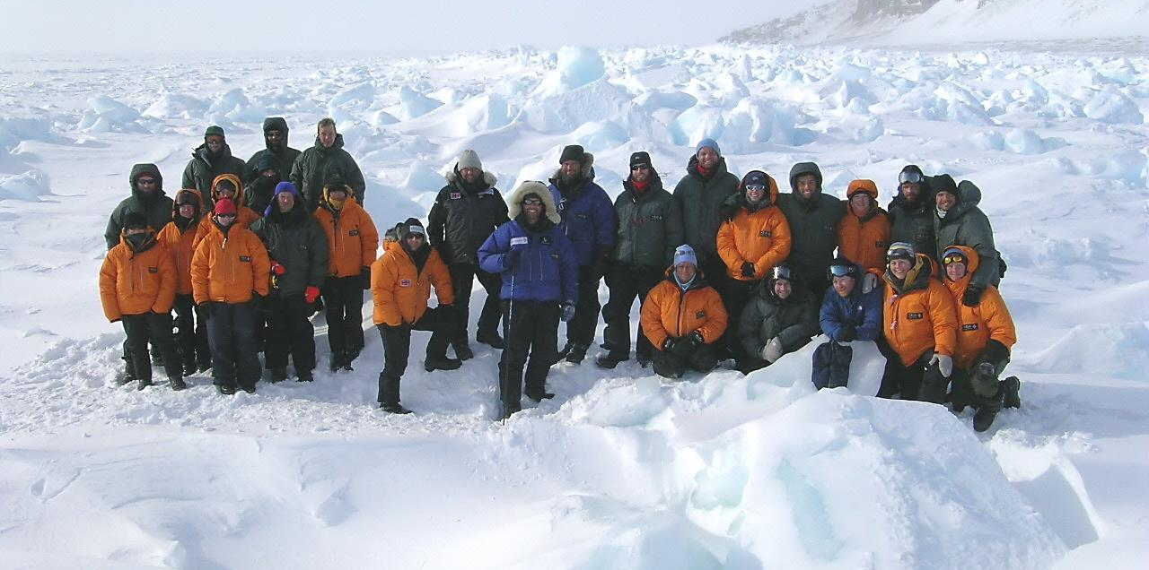
Inaccessible Pole Expedition

The “Unconquered Everest” of the Polar Regions and an essential transect of the Arctic Ocean

There is a place deep in the Arctic

Where mankind has yet to reach

A place that is furthest from land

The very centre of the Arctic Ocean

The Northern Pole of Inaccessibility

It is a journey of over 800 miles across treacherous sea-ice

In one of the most inhospitable environments on Earth

We’ll face frigid temperatures that will freeze flesh in seconds

Polar bears that will hunt us

And an Ocean that will swallow us up

It will take, perfect preparation, steely determination

Great team work and massive amounts of reserves to succeed

But when we make it, we’ll have achieved not only

A World First

But a vital benchmark for the scientific community and the measurement of Global Change

Jim McNeill will lead this extraordinary attempt in February 2019.

Few, if any, have the length and breadth of experience to pull this off.

And he has some innovative engineering to help him.

And you can take part in this historic event!

There are 28 committed people, in 4 teams of 7

Undertaking comprehensive training

And at least a 20 day leg of the expedition

These are ordinary people

From all walks of life

From many nations

United in singular purpose

True citizen science

Wholly fulfilling

A visual account of the Arctic Ocean

A vital data-set and benchmark

Televised by newscasters across the globe

Reported weekly by TV, Radio and Online media partners

This Not just another Polar Expedition

But a real contribution to the Present

And to our Future
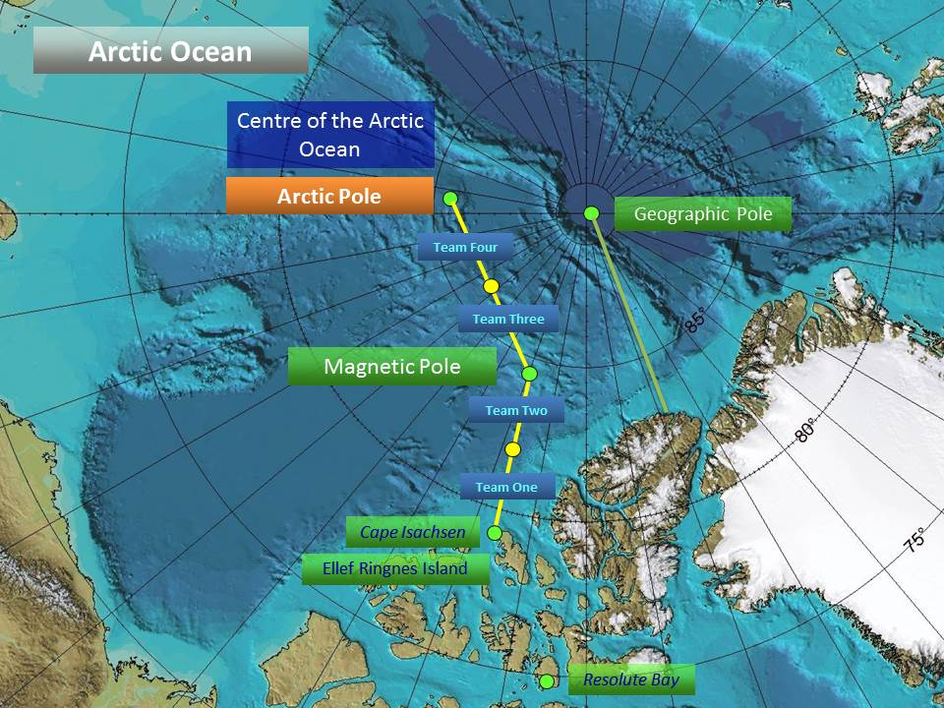
The Pole of Inaccessibility is named that for good reason.
Arguably one of the most important unfolding stories in the world’s media is the state of the Arctic Ocean. As an early warning indicator it is vital that we know what is happening to our Polar Regions and we continue to monitor them. Without such data how do we know anything we attempt to do to mitigate climate change is actually working?
This is a massive endeavour to be the first to reach the Northern Inaccessible Pole
The Northern Pole of Inaccessibility was first established by Sir Hubert Wilkins in 1927 when he wanted to traverse the Arctic Ocean by aircraft for the first time and therefore needed to know where the very centre of the ocean was. Obviously in 1927 the technology for establishing this furthest point from land was limited in its accuracy. In 2005 Jim McNeill, Ice Warrior’s Founder, had been working with NASA-sponsored US scientists from the National Snow and Ice Data Center to validate their satellite estimates of the degree of sea ice melting when he asked them to re-establish the exact position using the latest GPS and satellite technology. In doing so it identified that a number of islands off of the Russian coastline were missed out.
This changed the position from 84°03′N 174°51′W﻿ to 85°15‘N 176°09'E (note the new easterly longitude) and has now been ratified by The Scott Polar Research Institute and Cambridge University.
Join the Team
People Wanted for the Last True World First in the Polar Regions
One of the world’s most experienced and respected explorers, Jim McNeill, founder of the successful 17-year-old Ice Warrior Project is looking for experienced adventurers or complete novices to take part in an extraordinary exploration of the Arctic Ocean.
The Northern Pole of Inaccessibility remains the last significant place on earth as yet unreached by mankind. By definition it is the furthest point from land on the Arctic Ocean (the very centre) and 270 miles from the Geographic North Pole. The expedition will start in mid February 2019 and finish in May and is an 800-mile, 80-day expedition, divided into 4 legs of 20 days and team members are being sought for each of the legs. A fully comprehensive training programme will ensure that all participants are safe and competent polar travellers, gaining skills that will be really useful in both business and life.
“I am looking for determined people with the right attitude and commitment who have enough time to put in the effort required. It’s not easy, if it were, lots of people would be doing it and the pole would have been reached by now.” McNeill said.
Throughout the transect and under the guidance of the world’s leading scientific authorities, team members will be gathering brand-new, vital, scientific data to document the condition of the Arctic Ocean and establish a benchmark for scientists to compare year-on-year. The rationale being, if we are not monitoring the state of the Polar Regions how will we know if anything we are doing in our own back gardens to mitigate climate change is actually working?
Ice Warrior Selection
The next Selection is 14-16 September (Please note it is not compulsory to attend a Selection Weekend, just advisory)
Training Training consists of a 10-day Expedition Core Skills course (£1200), a week of Basic Polar Training (£1350) and a week of Advanced Polar Training (£1850), based in Svalbard together with a further Training Expedition TBA. Details on www.ice-warrior.com
Kit and Equipment (Individual) may total £3,500, depending on what you might have already. All Team kit is provided by Ice Warrior.
Expedition Contribution
Team members are also required to raise £12,000 each towards the overall cost of the expedition, which also requires commercial sponsorship, which Ice Warrior and team members are pursuing. Ice Warrior will train the team and furnish them with materials to raise sponsorship and media awareness and teach them how to do so.
So how do we pay for this? We ask people to get involved with every aspect of planning and achieving the polar expedition. This is all part of the Ice Warrior ethos and training. An inherent part of expeditioning is raising funds for the event and we train people, thoroughly, to go and seek personal sponsorship from their own company, community, friends and contacts - as much as they can – and provide all the materials and help to do so.
In addition to this, Ice Warrior is constantly seeking and securing corporate financial sponsorship.
“The total amount needed to take part is £20k and if someone told me when I first started polar exploration way back in 1984 that I could get out on the Arctic Ocean and take part in a World First for this amount I would have bitten their arm off!
This is a tremendous opportunity for someone looking for a life changing experience ending up with a whole new set of life skills and lifelong companions.” Jim McNeill

Next Steps
- Contact Jim at BASECAMP, to answer any questions you may have
- Register your interest with Becky Condron (Jim’s PA)

T: +44 (0)1822 890338 E: jim@ice-warrior.com E: Becky@ice-warrior.com
You will be invited to the Ice Warrior WhatsApp group and the Basecamp App that we use to manage the process and where you will find all sorts of materials.

Some of Our Supporters

Ice Warrior’s Patron - Sir Ranulph Fiennes

When Jim approached me with a brief note hinting of a 'large ambitious but realistic' polar project in the offing he left me with little idea as to what it was all about. But three things grabbed my immediate attention. 'Polar', 'World Firsts' and the fact that this was a British effort.

During my first conversation with Jim, I was impressed by his quiet confidence and solid enthusiasm. Since then I have come to learn of the determination, dexterity, skills and knowledge of Jim and the crew behind the project and am delighted to be associated with them. Ice Warrior has all the potential of a truly great British First. Slightly mad and eccentric in conception, thorough and precise in planning and likely to prove ingenious and resolved in execution.

I wish Jim and his team the very best of luck in their endeavours.

Alexandra Shackleton

My grandfather, Ernest Shackleton, is always identified with "White South"; yet in 1920 he was planning an expedition to a white north. He intended to seek out the Pole of Inaccessibility in the Beaufort Sea which Shackleton referred to as mare incognita and terra incognita. However problems with finance meant it was too late to go north in the season, so he went south.

He died at the outset of that expedition.

Nearly a century later, Jim McNeill of Ice Warrior is planning his third attempt on the Pole of Inaccessibility.

The terrain is exceptionally hostile and dangerous; but I am confident that Jim and his team will be successful not only in reaching the elusive pole; but in conducting an environmentally vital transect of the Arctic Ocean; for as Ernest Shackleton said "difficulties are just things to overcome”. (1907)

Michael Palin – Broadcaster and President of the Royal Geographical Society

“Learning to travel the hard way is not only the best way, but it’s also the most memorable. I greatly admire all of you for having a go – believe me you won’t forget the experience. Good luck.”

Boris Johnson, Mayor of London

This is a truly ground-breaking endeavour, with people from all walks of life and echelons of society taking part. This expedition is going to have ordinary people doing something extraordinary and I am delighted to support them. I urge everyone to get involved and support this expedition and wish Jim and his team the very best of British luck and God speed.

Zac Goldsmith MP Richmond Park and North Kingston

“Jim and his team are not only undertaking an extraordinary Great British endeavour in the true, traditional sense of the phrase, but they are doing it with genuine purpose. The data they’ll gather will deliver new evidence as to what is really happening and further our understanding of the sea-ice and its effect on climate change. I’m delighted to support them and wish them well. Best wishes and best of luck!”

Donal McIntyre - Broadcaster and reporter

“Ice Warrior represents the best of British. It represents the great eccentric adventurous spirit. It also represents pioneering endeavours and the struggle of triumph over adversity”

Lord Robert Winston

“What Jim McNeill and his team are doing is pioneering of the most advanced kind. Just as Cancer Research UK is genuinely pioneering new ways to treat cancer; what he is planning pushes man beyond the boundaries and will take him to the most inaccessible places on Earth.”

Scientific Partners so Far

The Met Office has been a pioneer for over 150 years.
As a world-leading weather and climate service, the Met Office works closely with governments, individuals and organisations of every size to share its expert scientific knowledge and advice.
Around the clock, around the world, millions of people need to know more about how the weather will affect them now and in the future – especially us!

The US based National Snow and Ice Data Center (NSIDC) supports research into our world's frozen realms: the snow, ice, glacier, frozen ground, and climate interactions that make up Earth's cryosphere. Scientific data, whether taken in the field or relayed from satellites orbiting Earth, form the foundation for the scientific research that informs the world about our planet and our climate systems. They have been our partner since 2005.
The Norwegian Polar Institute is Norway's central institution for research, environmental monitoring and mapping of the Polar Regions. The Institute is the Norwegian authorities' consultant and supplier of knowledge, and contributes to the best possible administration of Norwegian polar areas. We have counted polar bears since 2007 for NPI.

The Arctic and Antarctic Research Institute belongs to the Russian Federal Service for Hydrometeorology and Environmental Monitoring (Roshydromet). Organized in 1920, AARI is the oldest and the largest Russian research institution in the field of comprehensive studies of the Polar Regions and have assisted Jim and his team by providing vital logistical help http://www.aari.ru

The Scott Polar Research Institute is a centre of excellence in the study of the Arctic and specializes particularly in the relationship between glaciers, ice sheets and environmental change. Through the publication of its scientific research, advice to governmental bodies and via public outreach, SPRI helps educate and inform a worldwide audience about the Polar Regions and rapid changes they are undergoing.
Ice Warrior will raise funds for the Friends of Scott Polar Research Institute to support the work of polar scientists, historical research of the Institute and to the projection of that research through the outreach activities of the polar museum.

Summary

So far Ice Warrior has trained over 350 people from all walks of life to be safe, responsible and competent Polar travellers and explorers.

The whole process is an extraordinary journey of self-development, of real achievement, of learning and of comradeship.

I do hope that in reading this document Ice Warrior has captured your imagination and secured your support. I’m immensely proud of what we have achieved to date and am very excited by our ambitious plans to take Ice Warrior into areas that will further benefit not only our participants and our supporters but humanity in its fullest form.

Development

Discovery

Delivery

For further information contact Jim +44(0)777 565 1471
Email Jim@ice-warrior.com
Sponsorship

Leading the World in Environmental Concern

- Starting with the Last True World First – The Arctic Pole - the “unconquered Everest” of the Polar Regions; the forgotten pole – a vital scientific transect.
- Be seen as a primary facilitator of a world record setting polar expedition
- A truly unique endeavour attracting worldwide and sustained media coverage that will captivate and engage quantifiable audiences
- An inspirational story of ordinary people achieving extraordinary things
- A massive ROI – as proven with previous expeditions – at least 6:1 return
- A well founded long-term project with expanding, ambitious plans up to 2020
- A platform for applying leading edge technologies
- Brand Association with our strong Ice Warrior Brand
- Brand Extension – Ice Warrior becomes Desert Warrior, Mountain Warrior, Jungle Warrior
- Huge through-the-line marketing potential with awe inspiring Arctic Imagery
- Participative Sponsorship – involve your staff – second them!
- Product placement or corporate exposure in TV documentary, Book, DVD, etc.
- A crucial Environmental and Scientific Programme – see our scientific partners
- A proven Education Road Show – running since November 2003
- Exposure and Ambassadorship; Jim McNeill’s Keynote Speaking and Media interviews
- “Warrior Way” Corporate Leadership & Team Training – Ice Warrior Challenges in UK and Base Camps in Canada and Norway.
- Merchandising – dual branding opportunity
- Opportunity for our Sponsor to achieve a world record by being the first to fly to the Arctic Pole on the pick-up aircraft
Creative Concepts
The Ice Station, Jim’s Ambassadorship, IW App creation, Step-by-Step Campaign, QAJAQ production, Leaving Reception, Secondment of Staff and a TV Documentary Series.
Please contact Jim for further details – jim@ice-warrior.com

